pkgs <- **c**("ggplot2", "dplyr", "tidyr",

"mosaicData", "carData",

"VIM", "scales", "treemapify",

"gapminder", "ggmap", "choroplethr",

"choroplethrMaps", "CGPfunctions",

"ggcorrplot", "visreg",

"gcookbook", "forcats",

"survival", "survminer",

"ggalluvial", "ggridges",

"GGally", "superheat",

"waterfalls", "factoextra",

"networkD3", "ggthemes",

"hrbrthemes", "ggpol",

"ggbeeswarm")

**install.packages**(pkgs)

# R Data Frames

Data Frames are data displayed in a format as a table.

Data Frames can have different types of data inside it. While the first column can be character, the second and third can be numeric or logical. However, each column should have the same type of data.

Use the data.frame() function to create a data frame:

### Example

# Create a data frame  
Data_Frame <- data.frame (  
  Training = c("Strength", "Stamina", "Other"),  
  Pulse = c(100, 150, 120),  
  Duration = c(60, 30, 45)  
)  
  
# Print the data frame  
Data_Frame

## Summarize the Data

Use the summary() function to summarize the data from a Data Frame:

### Example

Data_Frame <- data.frame (  
  Training = c("Strength", "Stamina", "Other"),  
  Pulse = c(100, 150, 120),  
  Duration = c(60, 30, 45)  
)  
  
Data_Frame  
  
summary(Data_Frame)

You will learn more about the summary() function in the statistical part of the R tutorial.

## Access Items

We can use single brackets [ ], double brackets [[ ]] or $ to access columns from a data frame:

### Example

Data_Frame <- data.frame (  
  Training = c("Strength", "Stamina", "Other"),  
  Pulse = c(100, 150, 120),  
  Duration = c(60, 30, 45)  
)  
  
Data_Frame[1]  
  
Data_Frame[["Training"]]  
  
Data_Frame$Training

## Add Rows

Use the rbind() function to add new rows in a Data Frame:

### Example

Data_Frame <- data.frame (  
  Training = c("Strength", "Stamina", "Other"),  
  Pulse = c(100, 150, 120),  
  Duration = c(60, 30, 45)  
)  
  
# Add a new row  
New_row_DF <- rbind(Data_Frame, c("Strength", 110, 110))  
  
# Print the new row  
New_row_DF

**Add Columns**

Use the cbind() function to add new columns in a Data Frame:

### Example

Data_Frame <- data.frame (  
  Training = c("Strength", "Stamina", "Other"),  
  Pulse = c(100, 150, 120),  
  Duration = c(60, 30, 45)  
)  
  
# Add a new column  
New_col_DF <- cbind(Data_Frame, Steps = c(1000, 6000, 2000))  
  
# Print the new column  
New_col_DF

## Remove Rows and Columns

Use the c() function to remove rows and columns in a Data Frame:

### Example

Data_Frame <- data.frame (  
  Training = c("Strength", "Stamina", "Other"),  
  Pulse = c(100, 150, 120),  
  Duration = c(60, 30, 45)  
)  
  
# Remove the first row and column  
Data_Frame_New <- Data_Frame[-c(1), -c(1)]  
  
# Print the new data frame  
Data_Frame_New

## Amount of Rows and Columns

Use the dim() function to find the amount of rows and columns in a Data Frame:

### Example

Data_Frame <- data.frame (  
  Training = c("Strength", "Stamina", "Other"),  
  Pulse = c(100, 150, 120),  
  Duration = c(60, 30, 45)  
)  
  
dim(Data_Frame)

You can also use the ncol() function to find the number of columns and nrow() to find the number of rows:

### Example

Data_Frame <- data.frame (  
  Training = c("Strength", "Stamina", "Other"),  
  Pulse = c(100, 150, 120),  
  Duration = c(60, 30, 45)  
)  
  
ncol(Data_Frame)  
nrow(Data_Frame)

**Data Frame Length**

Use the length() function to find the number of columns in a Data Frame (similar to ncol()):

### Example

Data_Frame <- data.frame (  
  Training = c("Strength", "Stamina", "Other"),  
  Pulse = c(100, 150, 120),  
  Duration = c(60, 30, 45)  
)  
  
length(Data_Frame)

## Combining Data Frames

Use the rbind() function to combine two or more data frames in R vertically:

### Example

Data_Frame1 <- data.frame (  
  Training = c("Strength", "Stamina", "Other"),  
  Pulse = c(100, 150, 120),  
  Duration = c(60, 30, 45)  
)  
  
Data_Frame2 <- data.frame (  
  Training = c("Stamina", "Stamina", "Strength"),  
  Pulse = c(140, 150, 160),  
  Duration = c(30, 30, 20)  
)  
  
New_Data_Frame <- rbind(Data_Frame1, Data_Frame2)  
New_Data_Frame

And use the cbind() function to combine two or more data frames in R horizontally:

### Example

Data_Frame3 <- data.frame (  
  Training = c("Strength", "Stamina", "Other"),  
  Pulse = c(100, 150, 120),  
  Duration = c(60, 30, 45)  
)  
Data_Frame4 <- data.frame (  
  Steps = c(3000, 6000, 2000),  
  Calories = c(300, 400, 300)  
)  
New_Data_Frame1 <- cbind(Data_Frame3, Data_Frame4)  
New_Data_Frame1

In R the pie chart is created using the **pie()** function which takes positive numbers as a vector input. The additional parameters are used to control labels, color, title etc.

Syntax

The basic syntax for creating a pie-chart using the R is −

pie(x, labels, radius, main, col, clockwise)

Following is the description of the parameters used −

* **x** is a vector containing the numeric values used in the pie chart.
* **labels** is used to give description to the slices.
* **radius** indicates the radius of the circle of the pie chart.(value between −1 and +1).
* **main** indicates the title of the chart.
* **col** indicates the color palette.
* **clockwise** is a logical value indicating if the slices are drawn clockwise or anti clockwise.

Example

A very simple pie-chart is created using just the input vector and labels. The below script will create and save the pie chart in the current R working directory.

[Live Demo](http://tpcg.io/9RA309)

# Create data for the graph.

x <- c(21, 62, 10, 53)

labels <- c("London", "New York", "Singapore", "Mumbai")

# Give the chart file a name.

png(file = "city.png")

# Plot the chart.

pie(x,labels)

# Save the file.

dev.off()

When we execute the above code, it produces the following result −

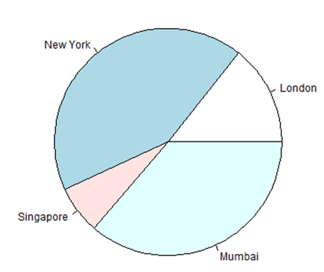

Pie Chart Title and Colors

We can expand the features of the chart by adding more parameters to the function. We will use parameter **main** to add a title to the chart and another parameter is **col** which will make use of rainbow colour pallet while drawing the chart. The length of the pallet should be same as the number of values we have for the chart. Hence we use length(x).

Example

The below script will create and save the pie chart in the current R working directory.

[Live Demo](http://tpcg.io/lfj0VZ)

# Create data for the graph.

x <- c(21, 62, 10, 53)

labels <- c("London", "New York", "Singapore", "Mumbai")

# Give the chart file a name.

png(file = "city_title_colours.jpg")

# Plot the chart with title and rainbow color pallet.

pie(x, labels, main = "City pie chart", col = rainbow(length(x)))

# Save the file.

dev.off()

When we execute the above code, it produces the following result −

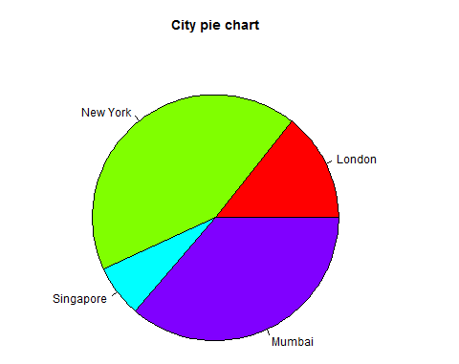

Slice Percentages and Chart Legend

We can add slice percentage and a chart legend by creating additional chart variables.

[Live Demo](http://tpcg.io/nu6DVu)

# Create data for the graph.

x <- c(21, 62, 10,53)

labels <- c("London","New York","Singapore","Mumbai")

piepercent<- round(100*x/sum(x), 1)

# Give the chart file a name.

png(file = "city_percentage_legends.jpg")

# Plot the chart.

pie(x, labels = piepercent, main = "City pie chart",col = rainbow(length(x)))

legend("topright", c("London","New York","Singapore","Mumbai"), cex = 0.8,

fill = rainbow(length(x)))

# Save the file.

dev.off()

When we execute the above code, it produces the following result −

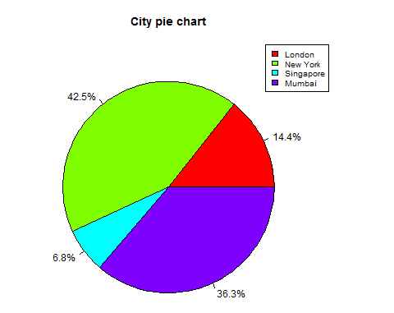

3D Pie Chart

A pie chart with 3 dimensions can be drawn using additional packages. The package **plotrix** has a function called **pie3D()** that is used for this.

# Get the library.

library(plotrix)

# Create data for the graph.

x <- c(21, 62, 10,53)

lbl <- c("London","New York","Singapore","Mumbai")

# Give the chart file a name.

png(file = "3d_pie_chart.jpg")

# Plot the chart.

pie3D(x,labels = lbl,explode = 0.1, main = "Pie Chart of Countries ")

# Save the file.

dev.off()

When we execute the above code, it produces the following result −

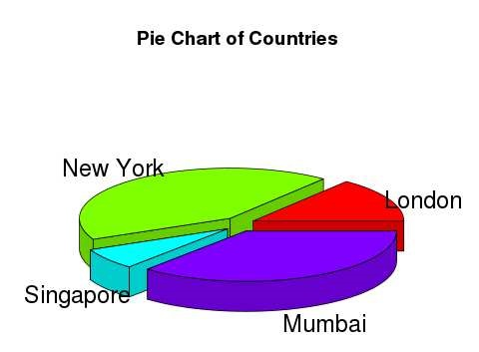

A bar chart represents data in rectangular bars with length of the bar proportional to the value of the variable. R uses the function **barplot()** to create bar charts. R can draw both vertical and Horizontal bars in the bar chart. In bar chart each of the bars can be given different colors.

Syntax

The basic syntax to create a bar-chart in R is −

barplot(H,xlab,ylab,main, names.arg,col)

Following is the description of the parameters used −

* **H** is a vector or matrix containing numeric values used in bar chart.
* **xlab** is the label for x axis.
* **ylab** is the label for y axis.
* **main** is the title of the bar chart.
* **names.arg** is a vector of names appearing under each bar.
* **col** is used to give colors to the bars in the graph.

Example

A simple bar chart is created using just the input vector and the name of each bar.

The below script will create and save the bar chart in the current R working directory.

[Live Demo](http://tpcg.io/jq3tAt)

# Create the data for the chart

H <- c(7,12,28,3,41)

# Give the chart file a name

png(file = "barchart.png")

# Plot the bar chart

barplot(H)

# Save the file

dev.off()

When we execute above code, it produces following result −

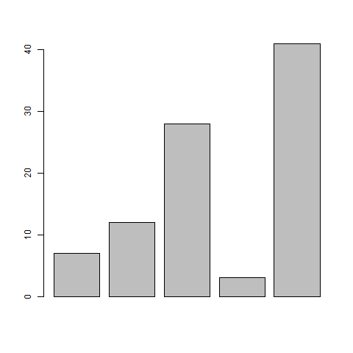

Bar Chart Labels, Title and Colors

The features of the bar chart can be expanded by adding more parameters. The **main** parameter is used to add **title**. The **col** parameter is used to add colors to the bars. The **args.name** is a vector having same number of values as the input vector to describe the meaning of each bar.

Example

The below script will create and save the bar chart in the current R working directory.

[Live Demo](http://tpcg.io/cbEAcG)

# Create the data for the chart

H <- c(7,12,28,3,41)

M <- c("Mar","Apr","May","Jun","Jul")

# Give the chart file a name

png(file = "barchart_months_revenue.png")

# Plot the bar chart

barplot(H,names.arg=M,xlab="Month",ylab="Revenue",col="blue",

main="Revenue chart",border="red")

# Save the file

dev.off()

When we execute above code, it produces following result −

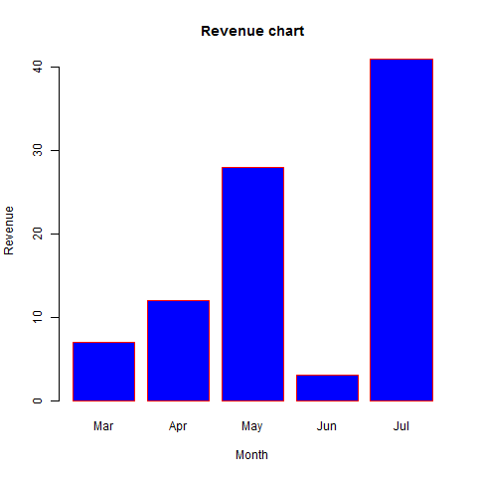

Group Bar Chart and Stacked Bar Chart

We can create bar chart with groups of bars and stacks in each bar by using a matrix as input values.

More than two variables are represented as a matrix which is used to create the group bar chart and stacked bar chart.

# Create the input vectors.

colors = c("green","orange","brown")

months <- c("Mar","Apr","May","Jun","Jul")

regions <- c("East","West","North")

# Create the matrix of the values.

Values <- matrix(c(2,9,3,11,9,4,8,7,3,12,5,2,8,10,11), nrow = 3, ncol = 5, byrow = TRUE)

# Give the chart file a name

png(file = "barchart_stacked.png")

# Create the bar chart

barplot(Values, main = "total revenue", names.arg = months, xlab = "month", ylab = "revenue", col = colors)

# Add the legend to the chart

legend("topleft", regions, cex = 1.3, fill = colors)

# Save the file

dev.off()

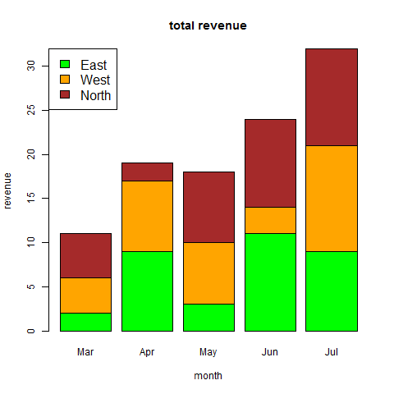

Boxplots are a measure of how well distributed is the data in a data set. It divides the data set into three quartiles. This graph represents the minimum, maximum, median, first quartile and third quartile in the data set. It is also useful in comparing the distribution of data across data sets by drawing boxplots for each of them.

Boxplots are created in R by using the **boxplot()** function.

Syntax

The basic syntax to create a boxplot in R is −

boxplot(x, data, notch, varwidth, names, main)

Following is the description of the parameters used −

* **x** is a vector or a formula.
* **data** is the data frame.
* **notch** is a logical value. Set as TRUE to draw a notch.
* **varwidth** is a logical value. Set as true to draw width of the box proportionate to the sample size.
* **names** are the group labels which will be printed under each boxplot.
* **main** is used to give a title to the graph.

Example

We use the data set "mtcars" available in the R environment to create a basic boxplot. Let's look at the columns "mpg" and "cyl" in mtcars.

[Live Demo](http://tpcg.io/5KQVSU)

input <- mtcars[,c('mpg','cyl')]

print(head(input))

When we execute above code, it produces following result −

mpg cyl

Mazda RX4 21.0 6

Mazda RX4 Wag 21.0 6

Datsun 710 22.8 4

Hornet 4 Drive 21.4 6

Hornet Sportabout 18.7 8

Valiant 18.1 6

Creating the Boxplot

The below script will create a boxplot graph for the relation between mpg (miles per gallon) and cyl (number of cylinders).

[Live Demo](http://tpcg.io/2HEgEU)

# Give the chart file a name.

png(file = "boxplot.png")

# Plot the chart.

boxplot(mpg ~ cyl, data = mtcars, xlab = "Number of Cylinders",

ylab = "Miles Per Gallon", main = "Mileage Data")

# Save the file.

dev.off()

When we execute the above code, it produces the following result −

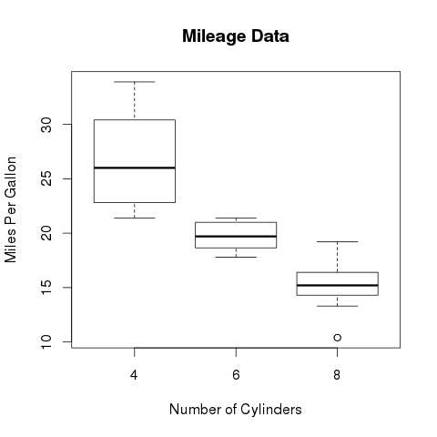

Boxplot with Notch

We can draw boxplot with notch to find out how the medians of different data groups match with each other.

The below script will create a boxplot graph with notch for each of the data group.

[Live Demo](http://tpcg.io/wvTPkv)

# Give the chart file a name.

png(file = "boxplot_with_notch.png")

# Plot the chart.

boxplot(mpg ~ cyl, data = mtcars,

xlab = "Number of Cylinders",

ylab = "Miles Per Gallon",

main = "Mileage Data",

notch = TRUE,

varwidth = TRUE,

col = c("green","yellow","purple"),

names = c("High","Medium","Low")

)

# Save the file.

dev.off()

When we execute the above code, it produces the following result −

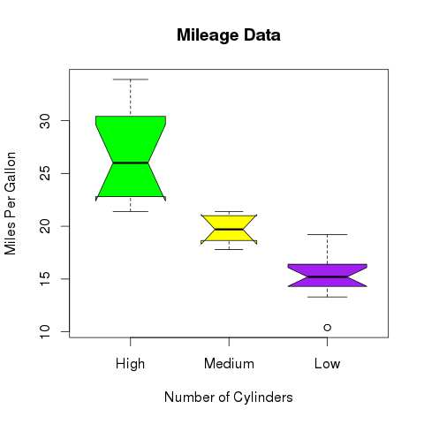

A histogram represents the frequencies of values of a variable bucketed into ranges. Histogram is similar to bar chat but the difference is it groups the values into continuous ranges. Each bar in histogram represents the height of the number of values present in that range.

R creates histogram using **hist()** function. This function takes a vector as an input and uses some more parameters to plot histograms.

Syntax

The basic syntax for creating a histogram using R is −

hist(v,main,xlab,xlim,ylim,breaks,col,border)

Following is the description of the parameters used −

* **v** is a vector containing numeric values used in histogram.
* **main** indicates title of the chart.
* **col** is used to set color of the bars.
* **border** is used to set border color of each bar.
* **xlab** is used to give description of x-axis.
* **xlim** is used to specify the range of values on the x-axis.
* **ylim** is used to specify the range of values on the y-axis.
* **breaks** is used to mention the width of each bar.

Example

A simple histogram is created using input vector, label, col and border parameters.

The script given below will create and save the histogram in the current R working directory.

[Live Demo](http://tpcg.io/UgZNBY)

# Create data for the graph.

v <- c(9,13,21,8,36,22,12,41,31,33,19)

# Give the chart file a name.

png(file = "histogram.png")

# Create the histogram.

hist(v,xlab = "Weight",col = "yellow",border = "blue")

# Save the file.

dev.off()

When we execute the above code, it produces the following result −

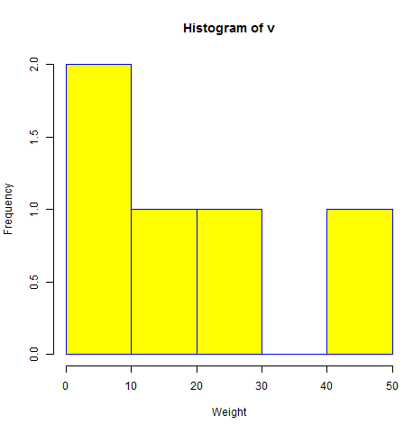

Range of X and Y values

To specify the range of values allowed in X axis and Y axis, we can use the xlim and ylim parameters.

The width of each of the bar can be decided by using breaks.

[Live Demo](http://tpcg.io/FpQHxd)

# Create data for the graph.

v <- c(9,13,21,8,36,22,12,41,31,33,19)

# Give the chart file a name.

png(file = "histogram_lim_breaks.png")

# Create the histogram.

hist(v,xlab = "Weight",col = "green",border = "red", xlim = c(0,40), ylim = c(0,5),

breaks = 5)

# Save the file.

dev.off()

When we execute the above code, it produces the following result −

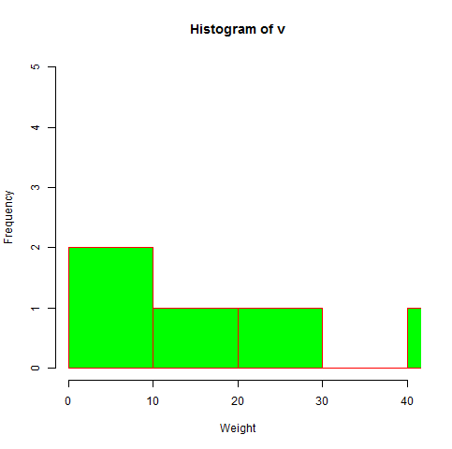

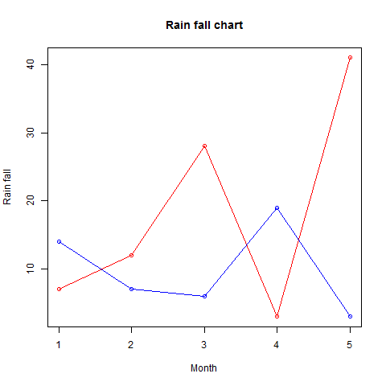

Scatterplots show many points plotted in the Cartesian plane. Each point represents the values of two variables. One variable is chosen in the horizontal axis and another in the vertical axis.

The simple scatterplot is created using the **plot()** function.

Syntax

The basic syntax for creating scatterplot in R is −

plot(x, y, main, xlab, ylab, xlim, ylim, axes)

Following is the description of the parameters used −

* **x** is the data set whose values are the horizontal coordinates.
* **y** is the data set whose values are the vertical coordinates.
* **main** is the tile of the graph.
* **xlab** is the label in the horizontal axis.
* **ylab** is the label in the vertical axis.
* **xlim** is the limits of the values of x used for plotting.
* **ylim** is the limits of the values of y used for plotting.
* **axes** indicates whether both axes should be drawn on the plot.

Example

We use the data set **"mtcars"** available in the R environment to create a basic scatterplot. Let's use the columns "wt" and "mpg" in mtcars.

[Live Demo](http://tpcg.io/dTE79b)

input <- mtcars[,c('wt','mpg')]

print(head(input))

When we execute the above code, it produces the following result −

wt mpg

Mazda RX4 2.620 21.0

Mazda RX4 Wag 2.875 21.0

Datsun 710 2.320 22.8

Hornet 4 Drive 3.215 21.4

Hornet Sportabout 3.440 18.7

Valiant 3.460 18.1

Creating the Scatterplot

The below script will create a scatterplot graph for the relation between wt(weight) and mpg(miles per gallon).

[Live Demo](http://tpcg.io/yVvVGa)

# Get the input values.

input <- mtcars[,c('wt','mpg')]

# Give the chart file a name.

png(file = "scatterplot.png")

# Plot the chart for cars with weight between 2.5 to 5 and mileage between 15 and 30.

plot(x = input$wt,y = input$mpg,

xlab = "Weight",

ylab = "Milage",

xlim = c(2.5,5),

ylim = c(15,30),

main = "Weight vs Milage"

)

# Save the file.

dev.off()

When we execute the above code, it produces the following result −

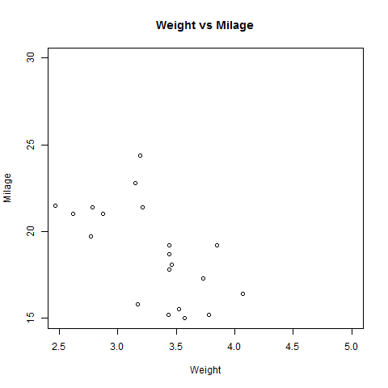

Scatterplot Matrices

When we have more than two variables and we want to find the correlation between one variable versus the remaining ones we use scatterplot matrix. We use **pairs()** function to create matrices of scatterplots.

Syntax

The basic syntax for creating scatterplot matrices in R is −

pairs(formula, data)

Following is the description of the parameters used −

* **formula** represents the series of variables used in pairs.
* **data** represents the data set from which the variables will be taken.

Example

Each variable is paired up with each of the remaining variable. A scatterplot is plotted for each pair.

[Live Demo](http://tpcg.io/aiaS5F)

# Give the chart file a name.

png(file = "scatterplot_matrices.png")

# Plot the matrices between 4 variables giving 12 plots.

# One variable with 3 others and total 4 variables.

pairs(~wt+mpg+disp+cyl,data = mtcars,

main = "Scatterplot Matrix")

# Save the file.

dev.off()

When the above code is executed we get the following output.

